**AKGEC/IAP/FM/02**

**AjayKumarGargEngineeringCollege, Ghaziabad**

**Department of Mechanical Engineering**

**SessionalTest-2**

Course :B.Tech Semester :VII

Session :2017-18 Section :ME-1,2, 3

Subject : Computer Aided Manufacturing Sub. Code :NME-031

Max Marks :50 Time : 2 hours

***Note*** : Answer**all**the Sections.

**Section-A**

1. Attempt **all**the parts. **5 X 2 = 10**
   1. Name important elements of NC machine tools.
   2. Discuss feedback devices and counting devices.
   3. Enlist any 10 G codes.
   4. Discuss Encoders and Transducers used in manufacturing industries
   5. Give limitations and benefits of NC machine tools compared to using alternative method.

**Section-B**

**2.** Attempt **all**the parts. **5X 5 = 25**

1. Explain functions of MCU in NC machine tools.
2. What is the difference between a closed-loop control system and an open-loop control system?
3. Briefly describe three phases of analog to digital conversion process with neat block diagram.
4. Discuss various types of NC motion control system with the help of suitable diagram.
5. Explain with the help of diagram/table, the principle of working of a circular interpolator.

**Section-C**

**3.** Attempt **all**the parts. **2 X 7.5 =15**

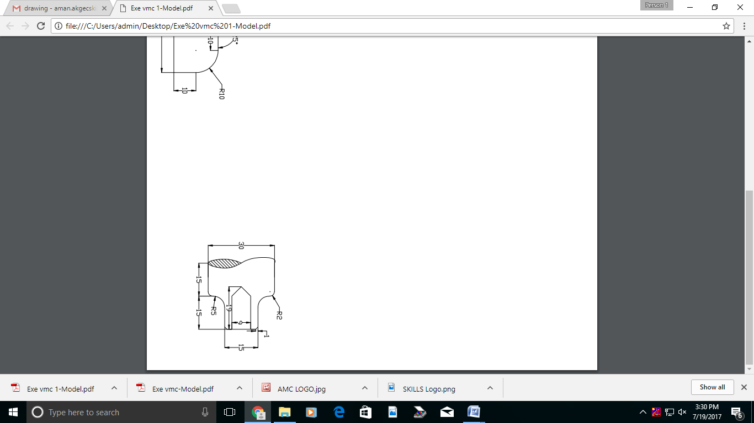

a. Writemanual part program for turning & drilling operation to make a shaft with dimensions shown in

figure below from the shaft of diameter 30mm (Assume feed and speed as required)

b. i) What is Adaptive Control? Under what conditions an adaptive control is recommended?

Discuss the ACC and ACO types of adaptive control with help of suitable examples.

ii) Explain the following terms related to NC Control system : Resolution, Accuracyand Repeatability.